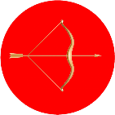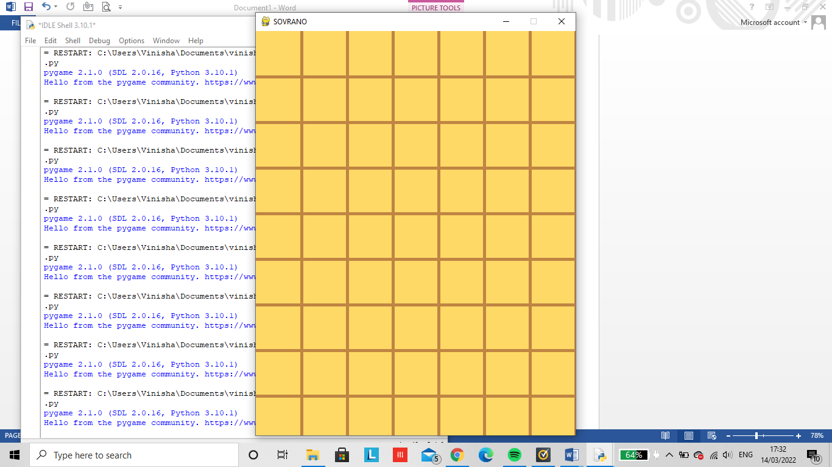

1

















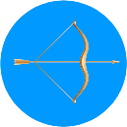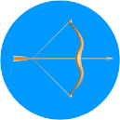

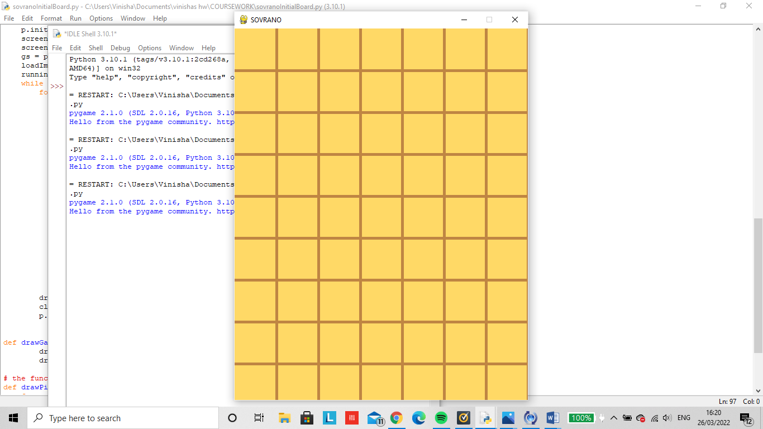

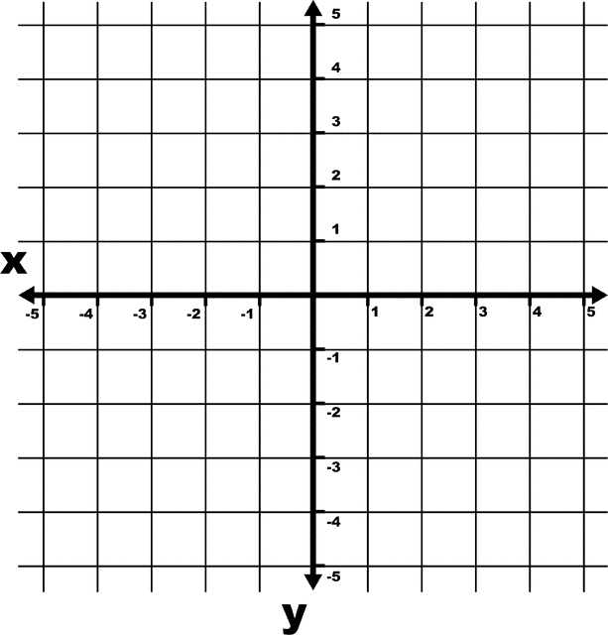

E



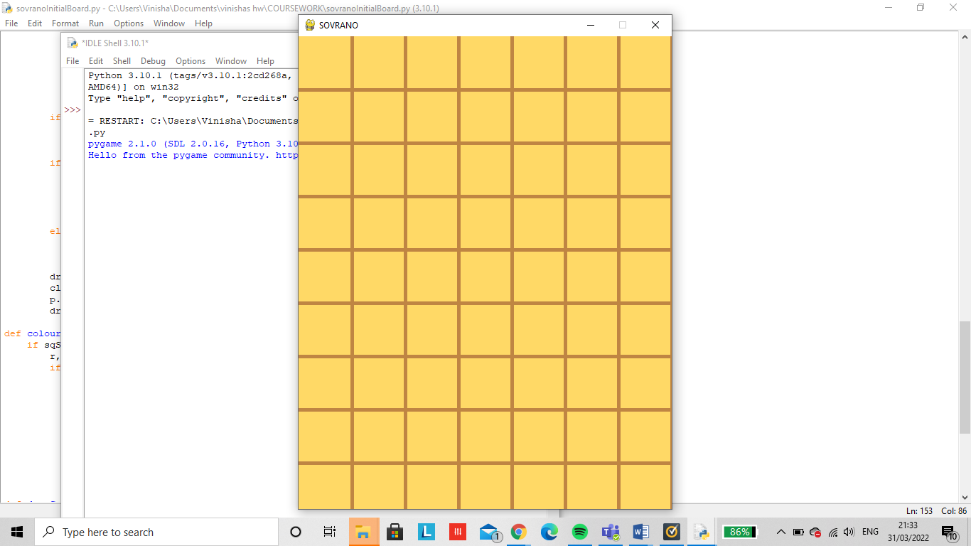

|  |  |  |
| --- | --- | --- |
|  |  |  |
|  |  |  |
|  |  |  |
|  |  |  |
|  |  |  |
|  |  |  |
|  |  |  |

LEADERBOARD

|  |  |  |
| --- | --- | --- |
| POSITION | USERNAME | SCORE |
| 1 | FIREBALL7 | 24 |
| 2 | BOB2003 | 23 |
| 3 | 5UPPP | 19 |
| 4 | XhjYOPLbN28 | 17 |
| 5 | mObIDlp7 | 11 |
| 6 | Ben10 | 4 |

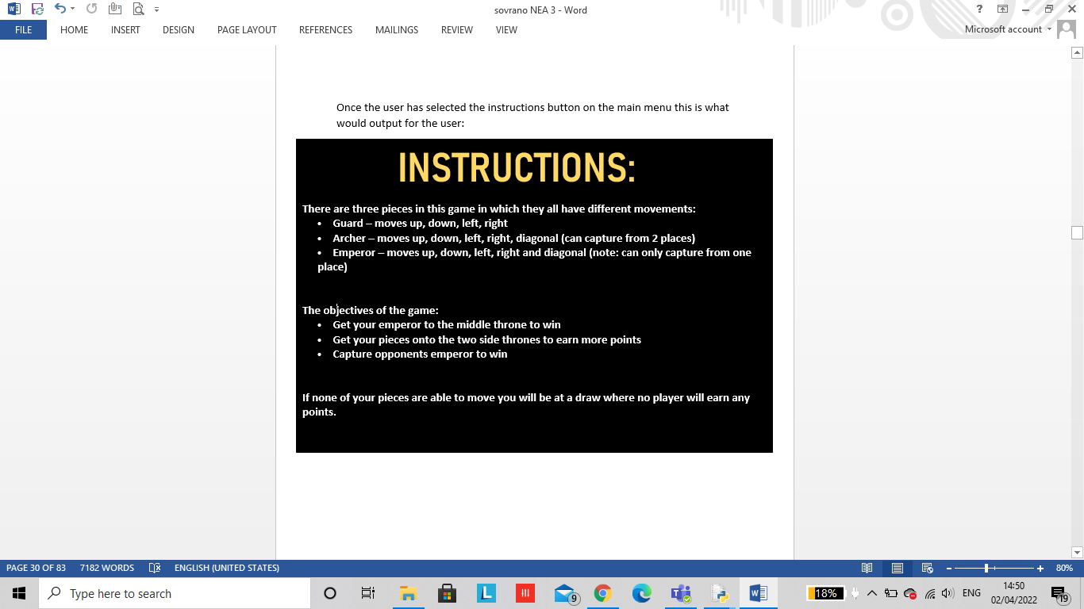

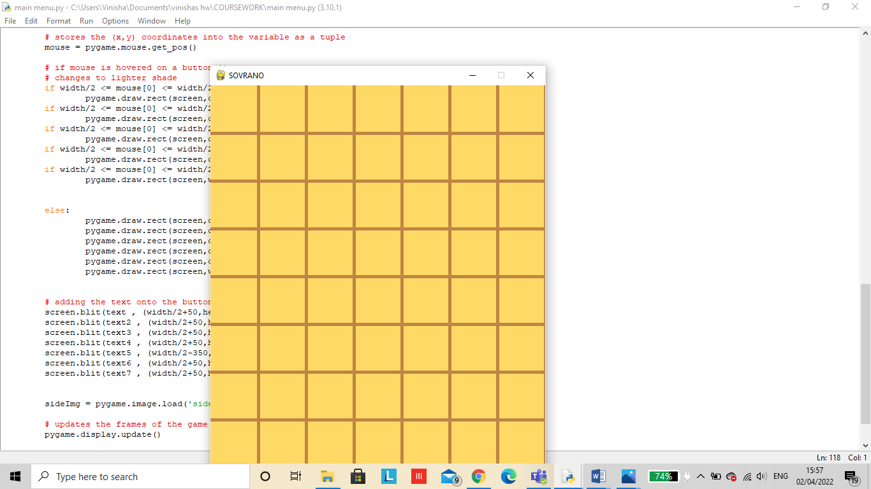

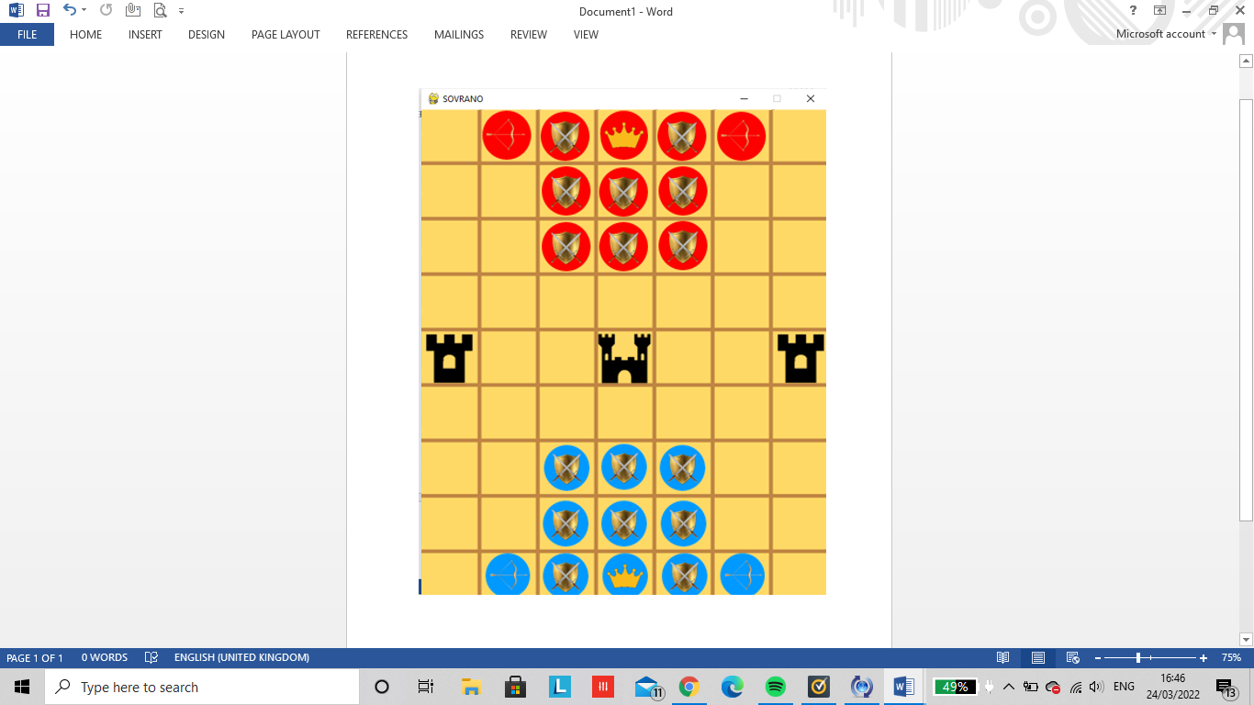

|  |  |  |  |  |
| --- | --- | --- | --- | --- |
| **USER MOVEMENTS** | **TEST DATA** | **ACTION** | **OUTCOME** | **HAS THE CRITERIA BEEN MET** |
| SELECTING A PIECE | VALID | Click on the start button with a mouse and select the start option | The sovrano game board is loaded onto the users screen | YES |
|  | INVALID | Selecting the ‘s’ or ‘1’ button on the keyboard | The sovrano game board wont load | YES |
|  | EXTREME | Clicking on the enter button when the mouse is hovered upon the option |  | YES |
| MOVING A PIECE | VALID | Click on the leader board button with a mouse and select the leader-board option |  | NO |
|  | INVALID | Selecting the ‘L’ or ‘2’ button on the keyboard |  | NO |
|  | EXTREME | Clicking on the enter button when the mouse is hovered upon the option |  | NO |
| CAPTURING A PIECE | VALID | Click on the instructions button with a mouse |  | YES |
|  | INVALID | Selecting the ‘L’ or ‘3’ button on the keyboard |  | YES |
|  | EXTREME | Clicking on the enter button when the mouse is hovered upon the option |  | YES |
| PAUSING GAME | VALID | Click on the quit button with users mouse |  | YES |
|  | INVALID | Selecting the ‘Q’ or ‘4’ button on the keyboard |  | YES |
|  | EXTREME |  |  | YES |
| RESUME GAME | INVALID | R is for reset |  |  |
|  |  |  |  |  |
|  |  |  |  |  |

|  |  |  |
| --- | --- | --- |
| VARIABLE NAME | JUSTIFICATION | DATA TYPE |
| pieces | Archer, guard, emperor, throne, middle throne | string |
| userTurn | blueToMove or redToMove | boolean |
| p.keydown | Undo/ reset/ pause/ resume | boolean |
| gameOver |  | boolean |
| Font |  | string |
| fontColour |  | integer |
| textPosition |  | integer |
| Self.capture |  | boolean |
| Self.draw |  | boolean |
| archerMoves |  | integer |
| emperorMoves |  |  |
| guardMoves |  |  |
| piecePoints |  |  |
| capture |  |  |
| draw |  |  |
| depth |  |  |
| score |  |  |